**Software Architecture and Design**

Course Work

ONLINE STORE SELLING FLOWERS

Variant - 11

*Prepared by:*

*students of SE-224B,*

*Anna Kuts’and*

*Alexander Trukhin*

*Accepted by:*

*Vasilieva M.D.*

# ANNOTATION

## Key words

Framework, json serialization, software patterns, class diagram, design system, build system, unit testing

## Course work structure

The work consists of such parts as: introduction, technical part, conclusion and used sources (6 sources). The technical part is divided into 2 two subparts: the first is common for both participants (software requirements and patterns) and the second is excellent, in some ways it seems common, but during development Oleksandr developed the backend, and Anna - the frontend.

Summery work is 21 papers and pictures in technical part.

## Object of development or research

The object of development is a web application for a flower shop, which allows users to view an assortment of flowers, search and filter products, add flowers and custom bouquets to the cart, place an order, and also receive notifications about the status of the order by mail.

## The purpose of the work

The goal of the work is to create an interactive and easy-to-use web application for a flower shop, which will ensure effective interaction of users with the range of products, facilitate the process of ordering and delivering flowers and bouquets.

## Research methods

Analysis of requirements: Conducting an analysis of the market and user requirements for similar web applications. Determination of the main functional and non-functional requirements for the system.

Architecture design: Designing the architecture of a web application.

Development: Use of modern web technologies to implement the functionality of the application. Using frameworks for frontend (Vue.js) and backend (Sendgrid email API).

Testing: Conducting JUnit unit software testing.

## The novelty of the project

The novelty of our project is the creation of custom bouquets in a special modal window for a better representation of the desired bouquet. We have not seen such an approach on any of the sites for the sale of flowers.

## Conclusions

We have developed a project - a web application for buying flowers and bouquets with all functionality except for payment. A cutting age approach to creating and ordering custom bouquets was applied. As well as the created admin menu for managing orders and products.

**CONTENT**

ANNOTATION 2

Key words 2

Course work structure 2

Object of development or research 2

The purpose of the work 2

Research methods 2

The novelty of the project 2

Conclusions 2

INTRODUCTION 4

TECHNICAL TASK: PART 1 5

Software requirements specification 5

Design patterns 6

Builder pattern 6

Singleton pattern 7

Decorator pattern 8

TECHNICAL TASK: PART 2 9

Build system in the project 9

Backend frameworks that we use in project 9

Representation of functional requirements 9

Representation of non-functional requirements 18

Unit tests for business logic 20

CONCLUSION 21

GitHubRepository: 21

REFERENCES 21

# INTRODUCTION

In this course work, we developed a site for selling flowers. In addition to the functional requirements in the task, we added: creation of custom bouquets, and menu admin to manage orders and flower products. The Maven build system was chosen to create a Java project. And for representation, they chose an interface - a web application.

# TECHNICAL TASK: PART 1

## Software requirements specification

|  |  |
| --- | --- |
| F 1 | Viewing the assortment of flowers |
| F 1.1 | Ability to view a variety of colors available for purchase |
| F 1.2 | Categorization of flowers by type, color, seasonality, etc |
| F 1.3 | Displaying detailed information about each type of flower (name, description, price, size, etc.) |
| F 1.4 | Photos of flowers for a better visual presentation |
| F 2 | Create custom bunch |
| F 2.1 | Control of the number of added flowers and total cost of bunch |
| F 2.2 | Custom bunch builder window for better customization, usability |
| F 2.3 | Photo of custom bunch for a better visual presentation |
| F 2.4 | Adding bunch to the basket |
| F 3 | Search and filtering |
| F 3.1 | Ability to search flowers by name, color, price etc |
| F 3.2 | Color filtering by various parameters |
| F 4 | Adding flowers to the basket |
| F 4.1 | The possibility of adding flowers to the basket for further processing of the order |
| F 4.2 | Control of the number of added flowers and their total cost |
| F 5 | Placing an order |
| F 5.1 | Filling out the form with the buyer's contact information and delivery address |
| F 5.2 | Choice of delivery method (courier delivery, pickup, postal delivery,etc.) |
| F 5.3 | Choice of payment method (online payment, cash on delivery, etc.) |
| F 6 | Order confirmation |
| F 6.1 | Sending confirmation of receipt of the order by e-mail |
| F 7 | Notification system |
| F 7.1 | Sending notifications to users about the status of their order (accepted, paid, in processing, shipped, delivered) |
| F 8 | Admin menu |
| F 8.1 | Interact with orders |
| F 8.1.1 | Show list of orders |
| F 8.1.2 | Show specific order |
| F 8.1.3 | Update status of specific order |
| F 8.1.4 | Sent email notification of update status in specific order |
| F 8.1.5 | Delete specific order |
| F 8.2 | Interact with products |
| F 8.2.1 | Show list of products |
| F 8.2.2 | Show specific product |
| F 8.2.3 | Update information and photo about product |
| F 8.2.4 | Delete specific product |
| F 8.2.5 | Add new product |
| NF 1 | The user interface should be intuitive and easy to use |
| NF 2 | The system should have documentation for developers |
| NF 3 | The email notification system should process user requests in no more than 1 minute |
| NF 4 | The site must be compatible with the main web browsers (Chrome, Firefox, Safari, Edge) |
| NF 5 | Modularity |
| NF 5.1 | Site architecture should be modular to facilitate testing, maintenance and development |
| NF 5.2 | Each site module must have clearly defined interfaces for interaction with other modules |
| NF 6 | Design system |

## Design patterns

### Builder pattern

We used Builder patterns for step-by-step creation of objects - flower, bouquet and order.

Bunch Builder:

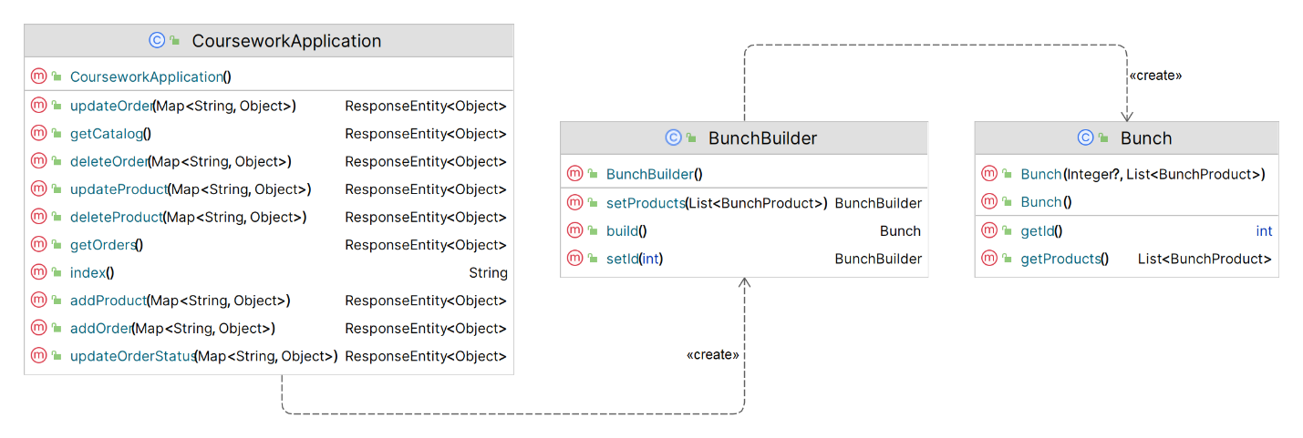

Product Builder:

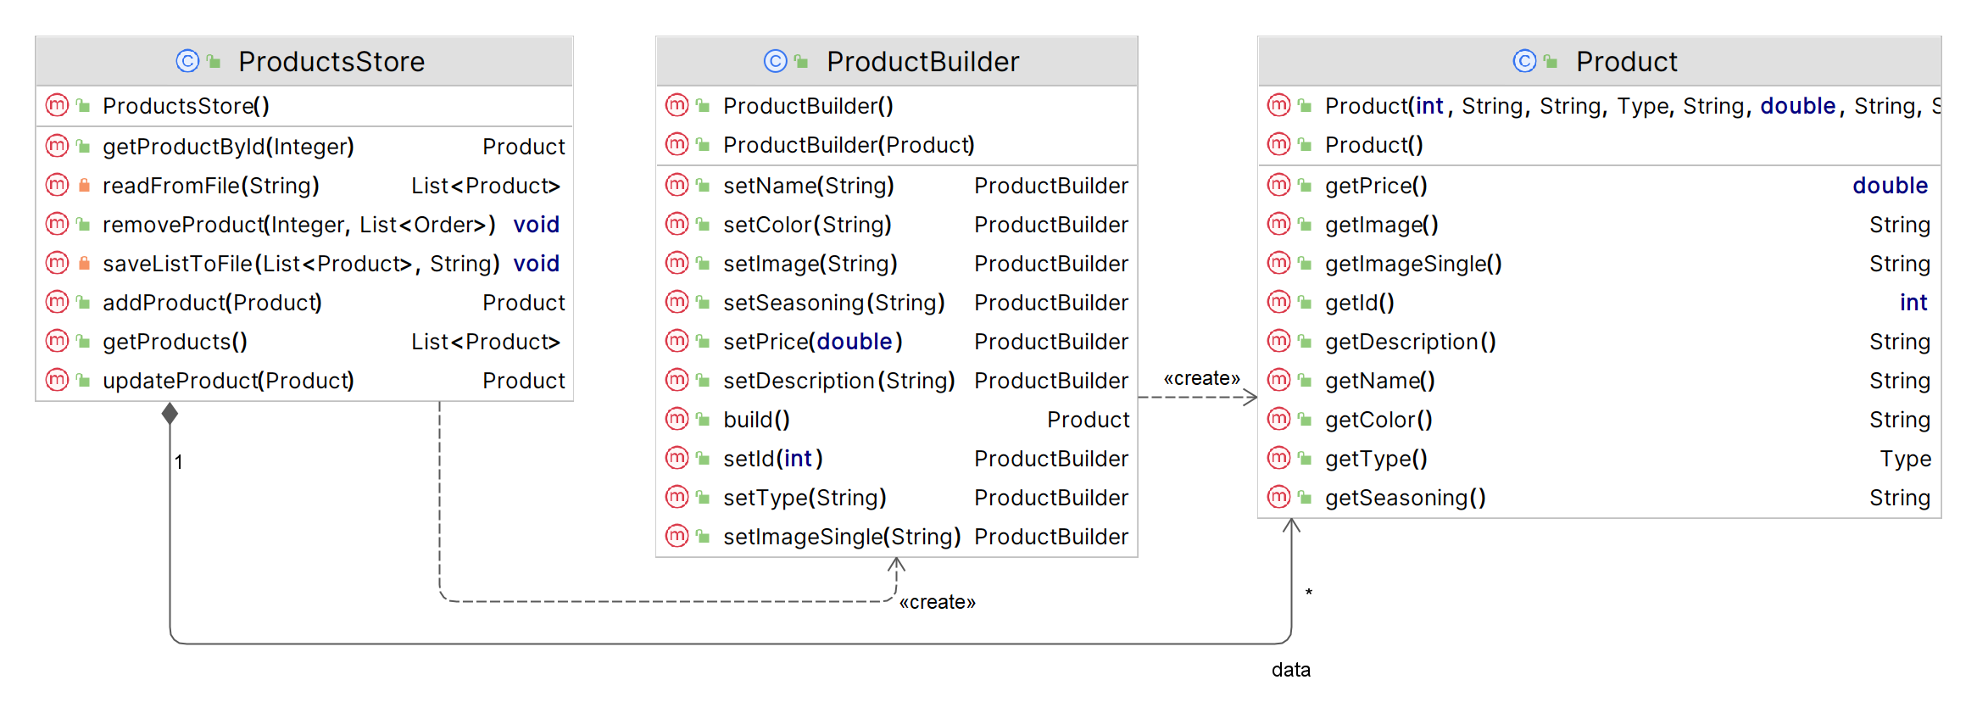

Order Builder:

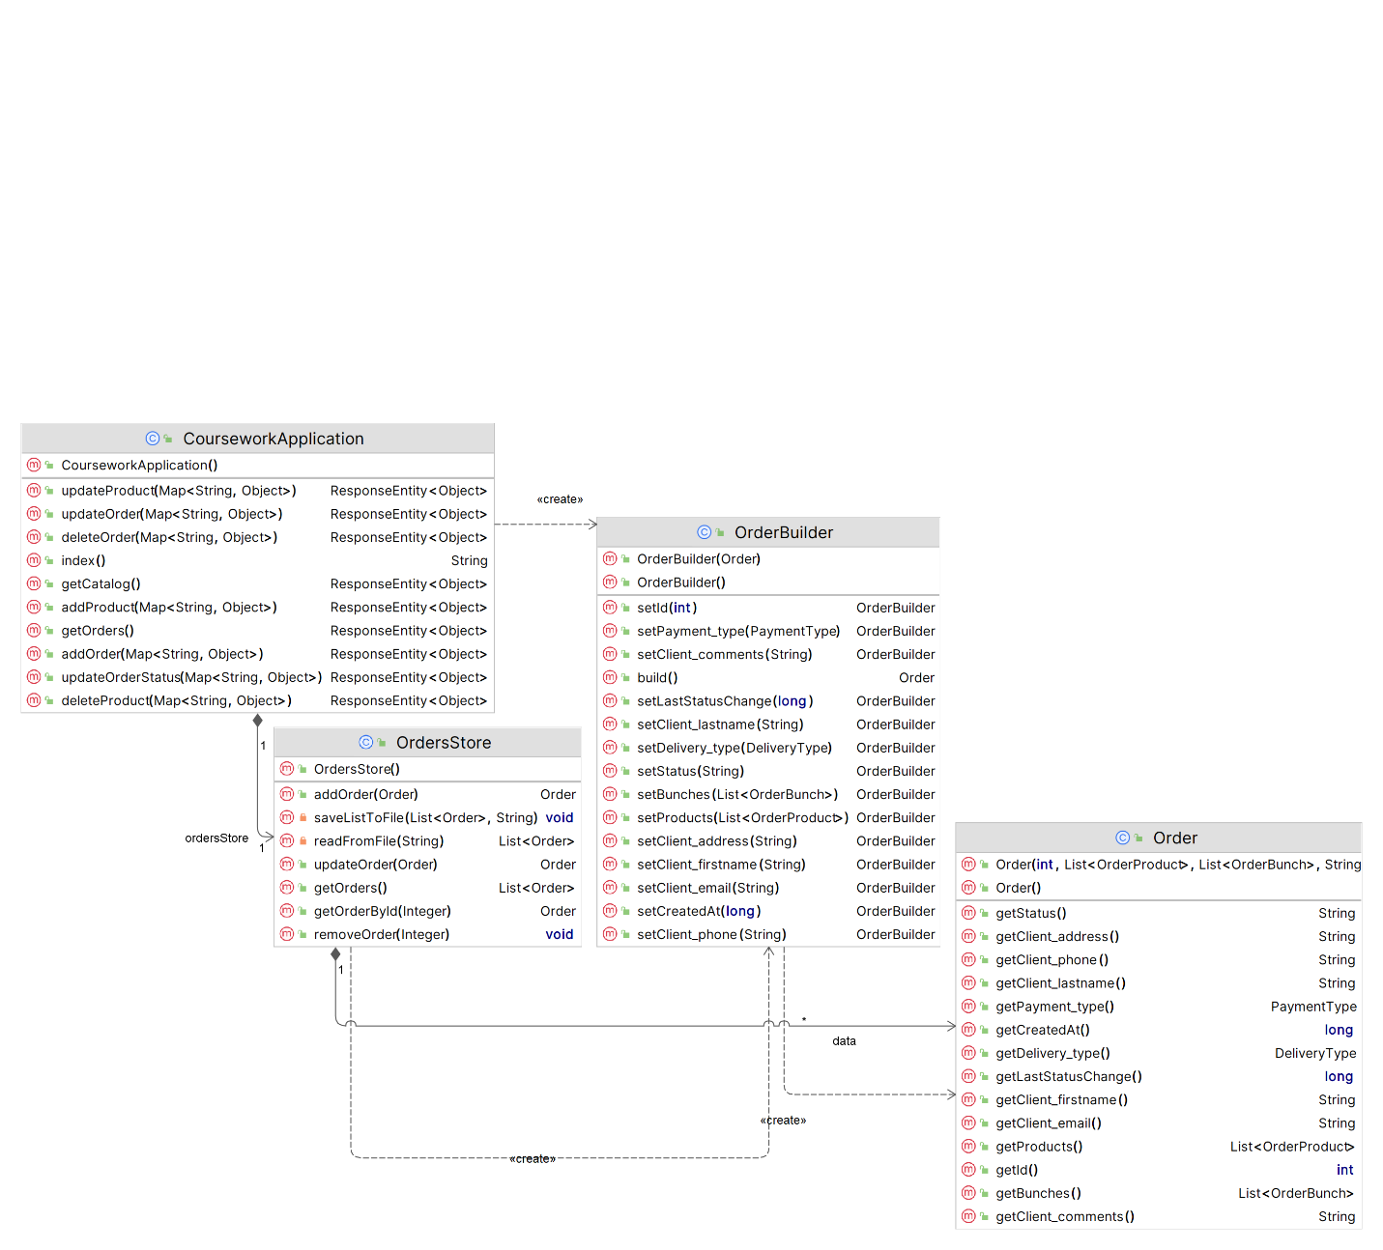

### Singleton pattern

We used the Singleton pattern so that there was only one instance of the class interacting with the database.

Orders Store Singleton:

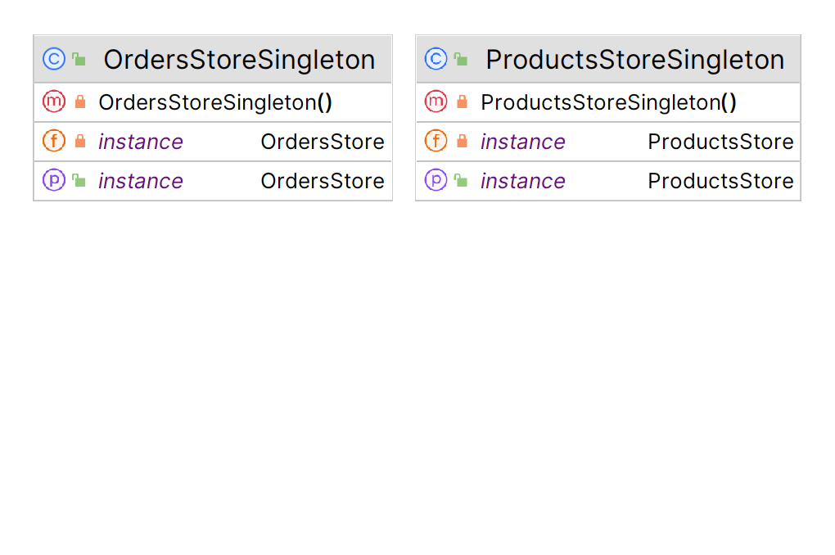

Products Store Singleton:



### Decorator pattern

We used the Decorator pattern, for the perspective of developing the catalog of bouquets and, to the application - adding a wrapper, now we have only 1 "decorator" - the number of identical bouquets, which are already a complex object (an array of various flowers).

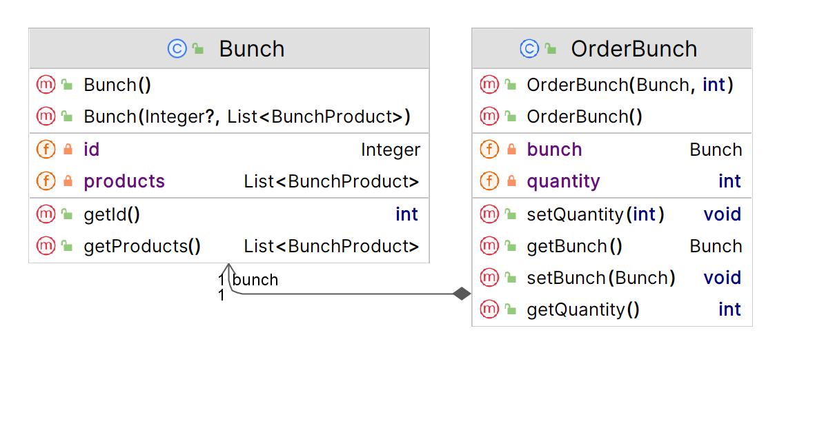

# TECHNICAL TASK: PART 2

## Build system in the project

We used the Maven build system to build the Java project.

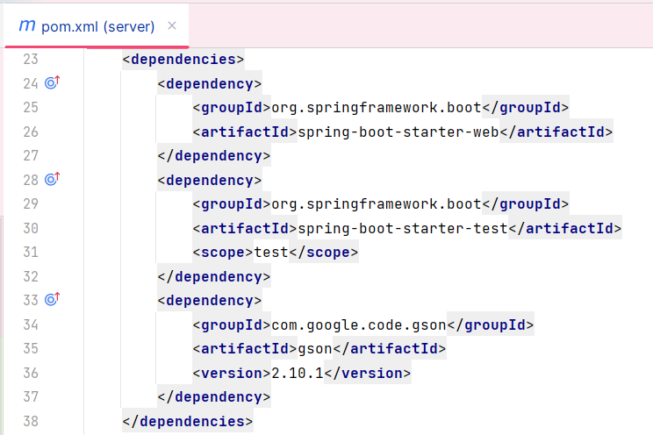

## Backend frameworks that we use in project

In our project, we used Java Spring Boot - a framework that simplifies the use of Java-based platforms for creating microservices and web applications.

## Representation of functional requirements

F 1 Viewing the assortment of flowers

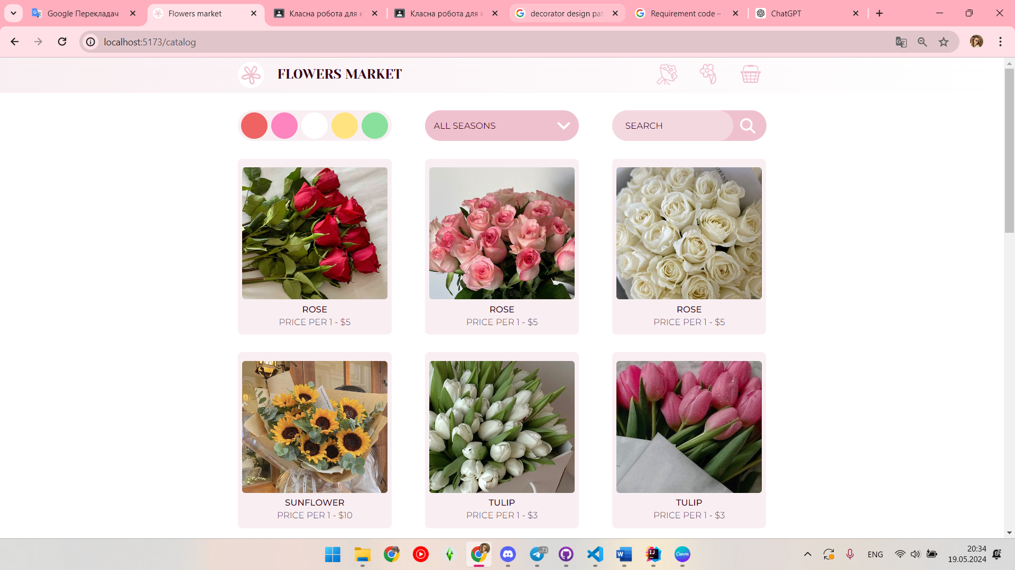

F 1.1 Ability to view a variety of colors available for purchase

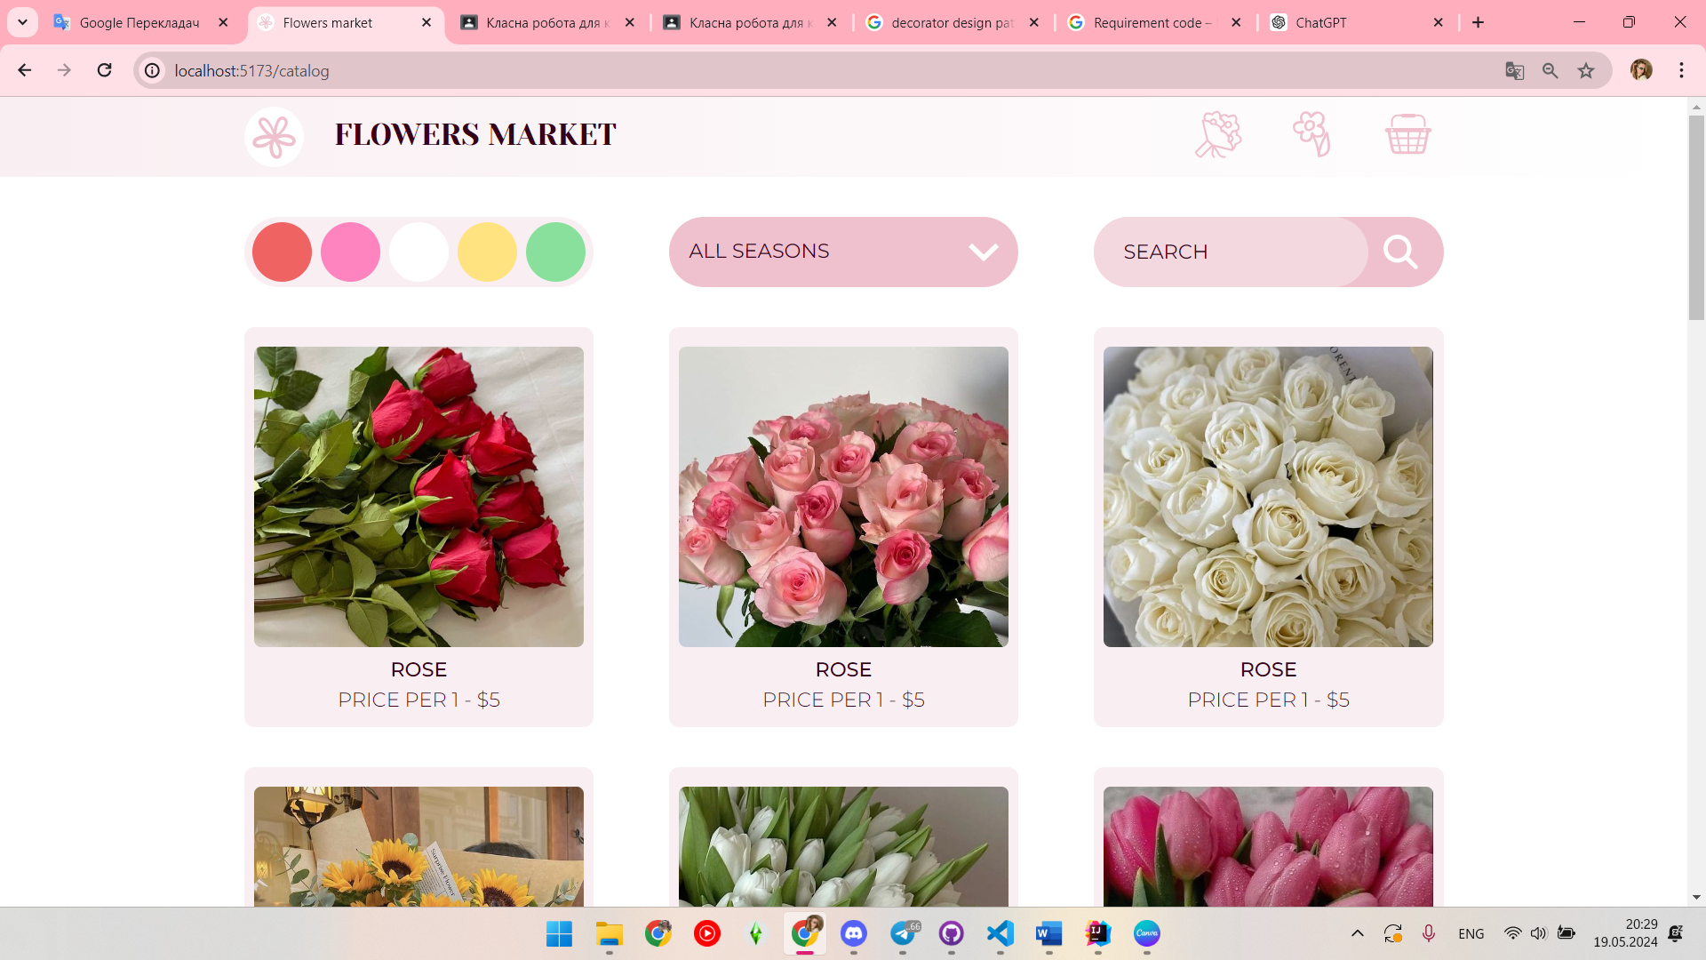

F 1.2 Categorization of flowers by type, color, seasonality, etc

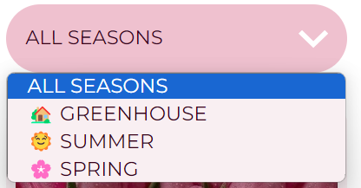

F 1.3 Displaying detailed information about each type of flower (name, description, price, size, etc.)

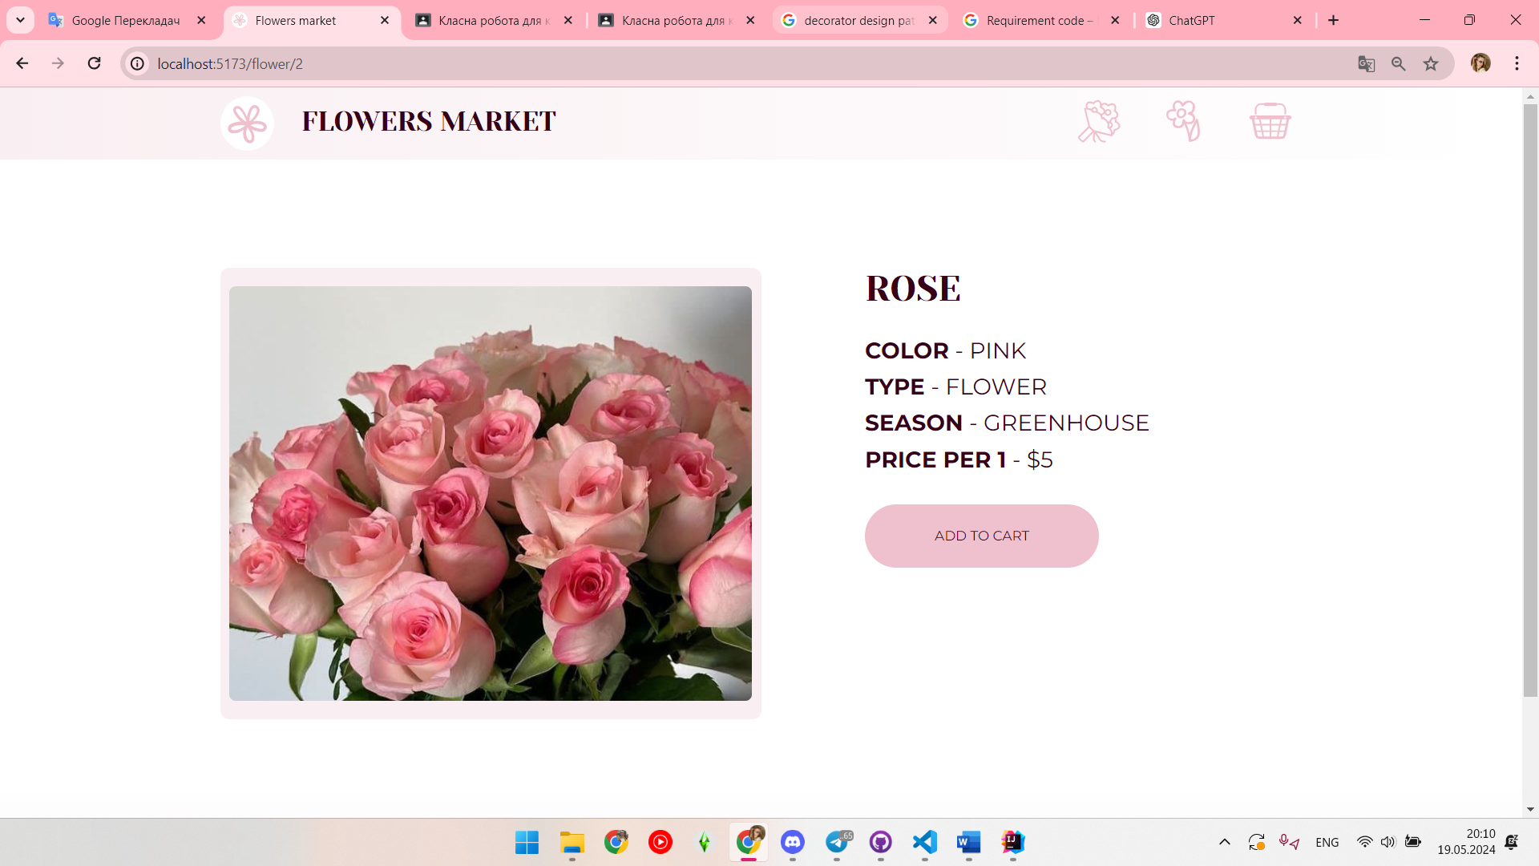

F 1.4 Photos of flowers for a better visual presentation

F 2 Create custom bunch

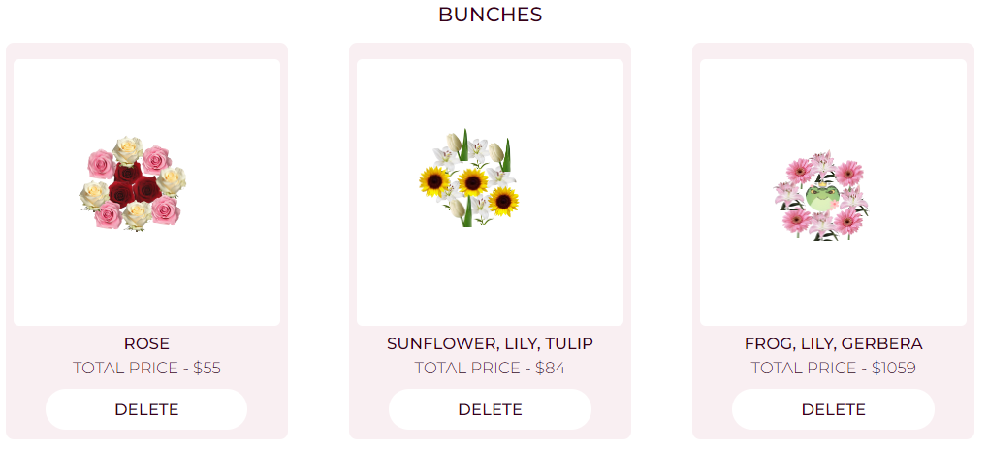

F 2.1 Control of the number of added flowers and total cost of bunch

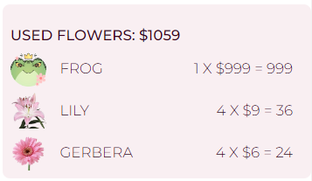

F 2.2 Custom bunch builder window for better customization, usability

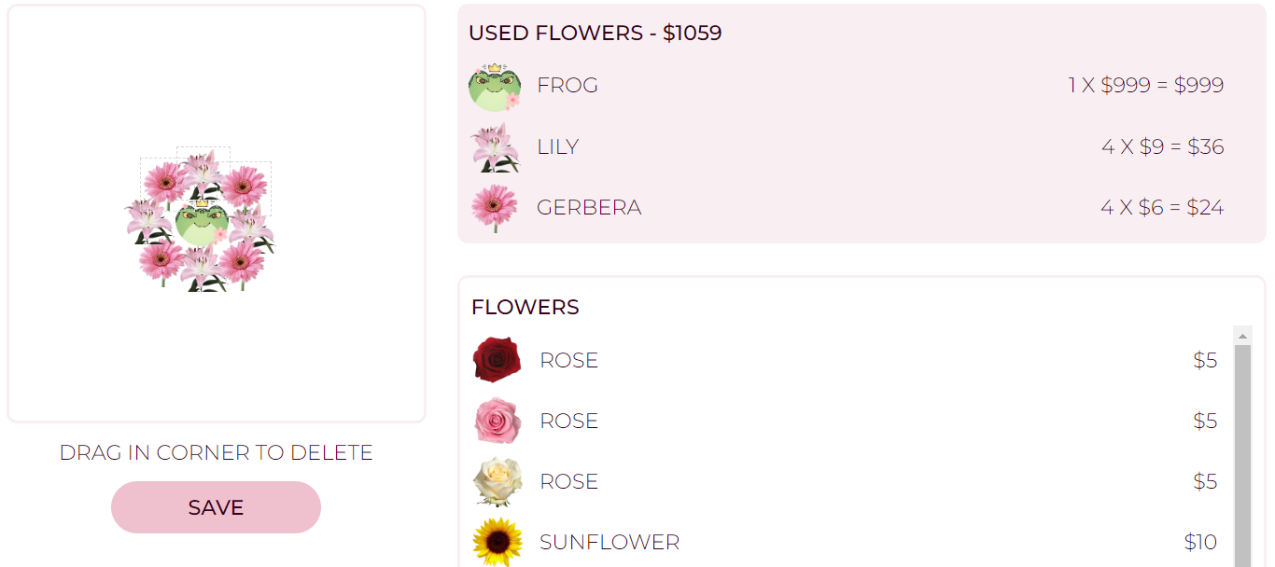

F 2.3 Photo of custom bunch for a better visual presentation

F 2.4 Adding bunch to the basket

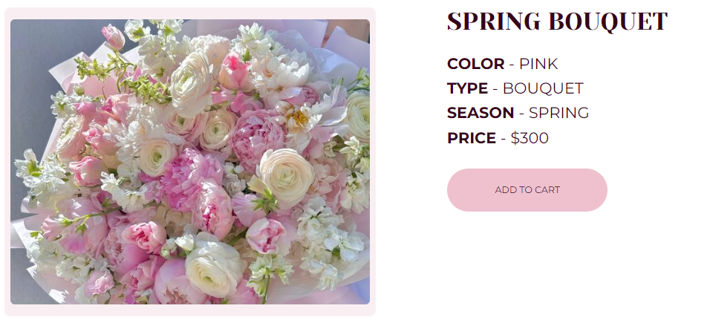

F 3 Search and filtering

F 3.1 Ability to search flowers by name, color, price etc



F 3.2 Color filtering by various parameters

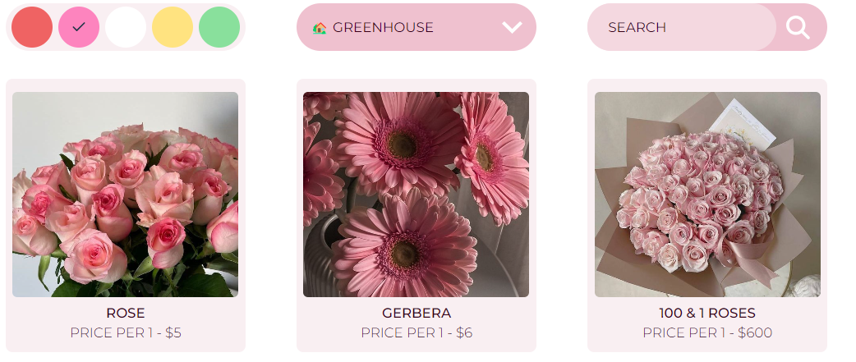

F 4 Adding flowers to the basket

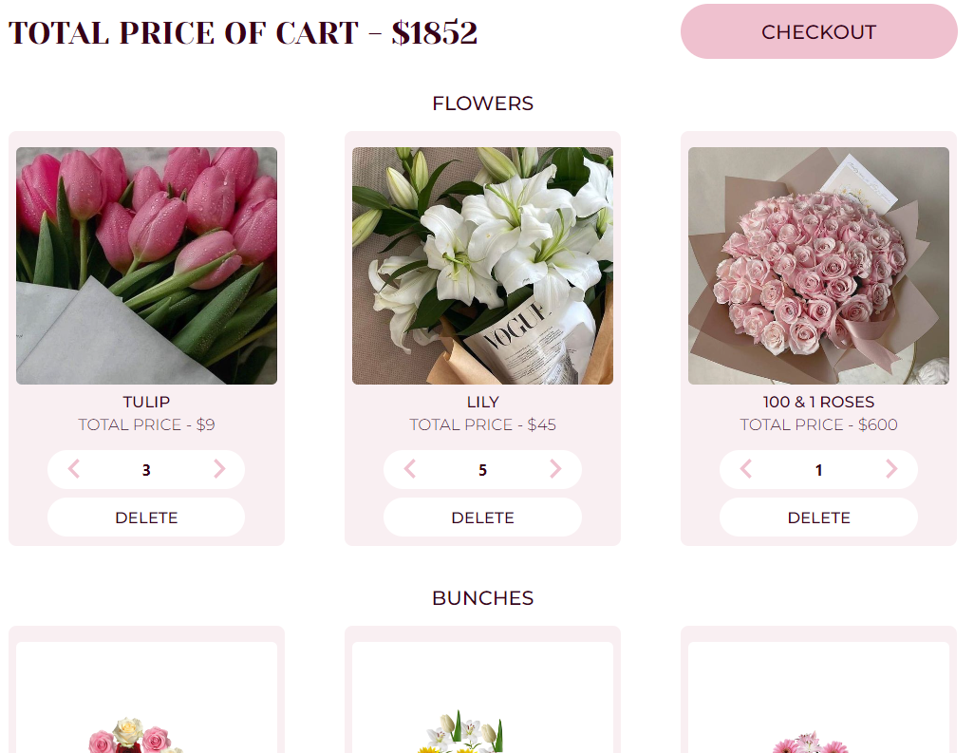

F 4.1 The possibility of adding flowers to the basket for further processing of the order

F 4.2 Control of the number of added flowers and their total cost

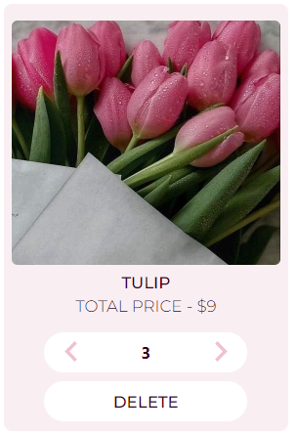

F 5 Placing an order

F 5.1 Filling out the form with the buyer's contact information and delivery address

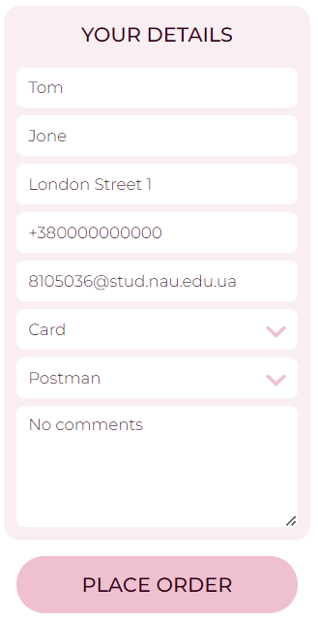

F 5.2 Choice of delivery method (courier delivery, pickup, postal delivery,etc.)

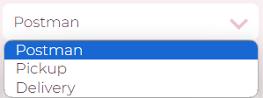

F 5.3 Choice of payment method (online payment, cash on delivery, etc.)

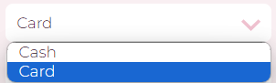

F 6 Order confirmation

F 6.1 Sending confirmation of receipt of the order by e-mail

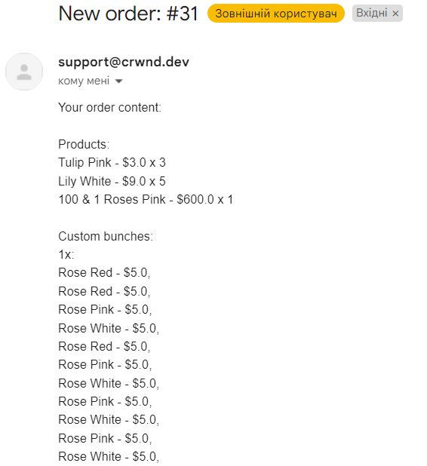

F 7 Notification system

F 7.1 Sending notifications to users about the status of their order (accepted, paid, in processing, shipped, delivered)



F 8 Admin menu

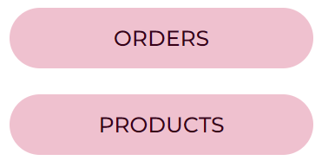

F 8.1 Interact with orders

F 8.1.1 Show list of orders

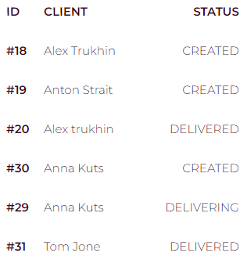

F 8.1.2 Show specific order

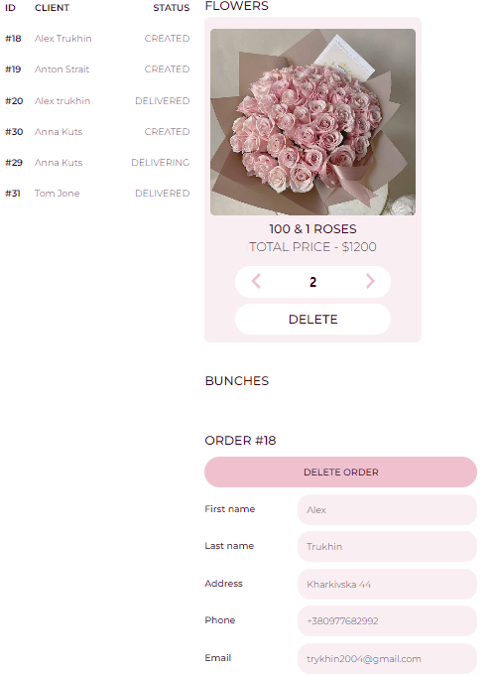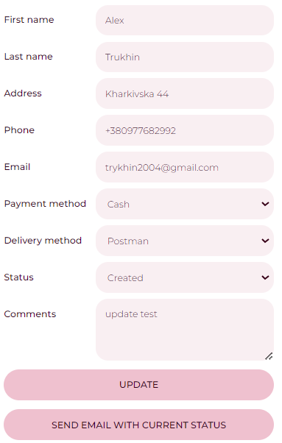

F 8.1.3 Update status of specific order

F 8.1.4 Sent email notification of update status in specific order

F 8.1.5 Delete specific order

F 8.2 Interact with products

F 8.2.1 Show list of products

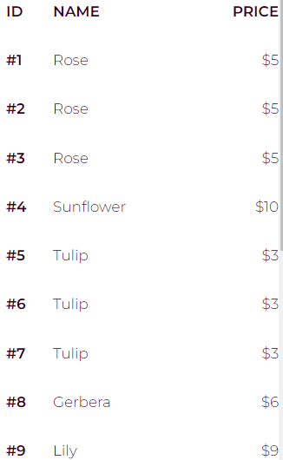

F 8.2.2 Show specific product

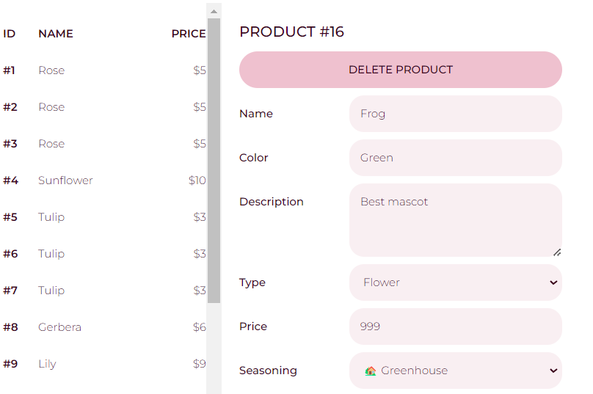

F 8.2.3 Update information and photo about product

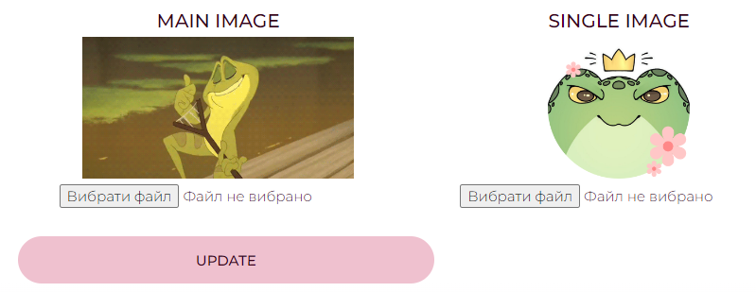

F 8.2.4 Delete specific product

F 8.2.5 Add new product

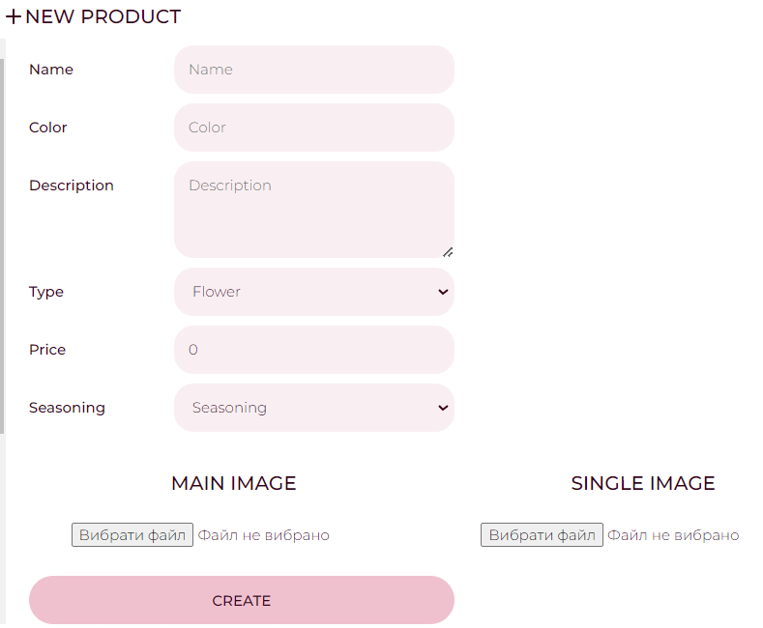

## Representation of non-functional requirements

NF 1 The user interface should be intuitive and easy to use

For ease of use, the website includes a header with basic buttons.

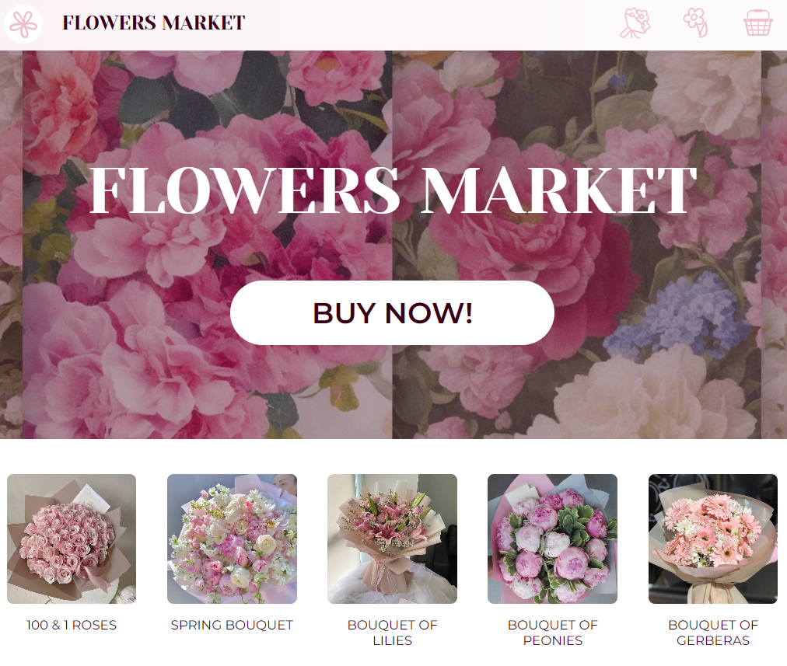

NF 2 The system should have documentation for developers

The entire Java project is documented using JavaDoс.

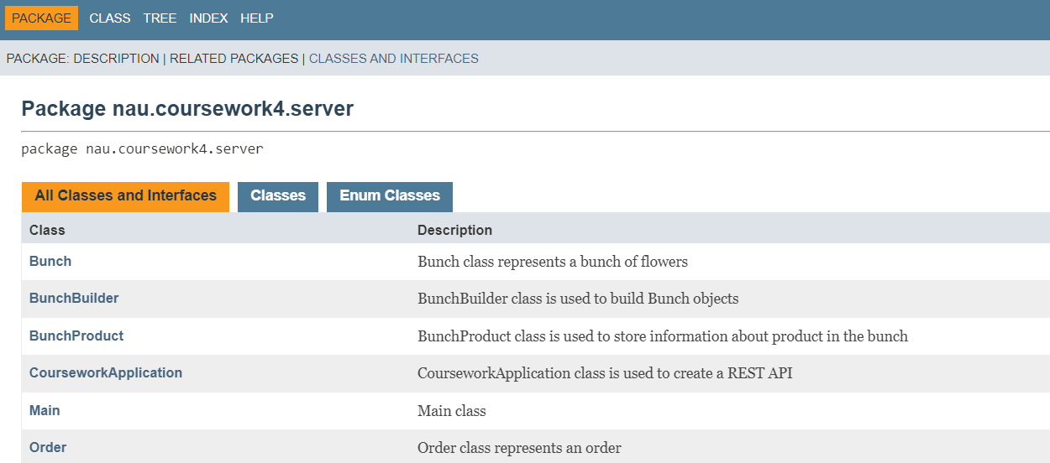

NF 3 The email notification system should process user requests in no more than 1 minute

NF 4 The site must be compatible with the main web browsers (Chrome, Firefox, Safari, Edge)

NF 5 Modularity

Our project uses a modular API system at the backend level, and Vue components at the frontend level.

NF 5.1 Site architecture should be modular to facilitate testing, maintenance and development

NF 5.2 Each site module must have clearly defined interfaces for interaction with other modules

**Details of creating an email notification system**

In the project, we used the Sendgrid service and HTTP API from it.

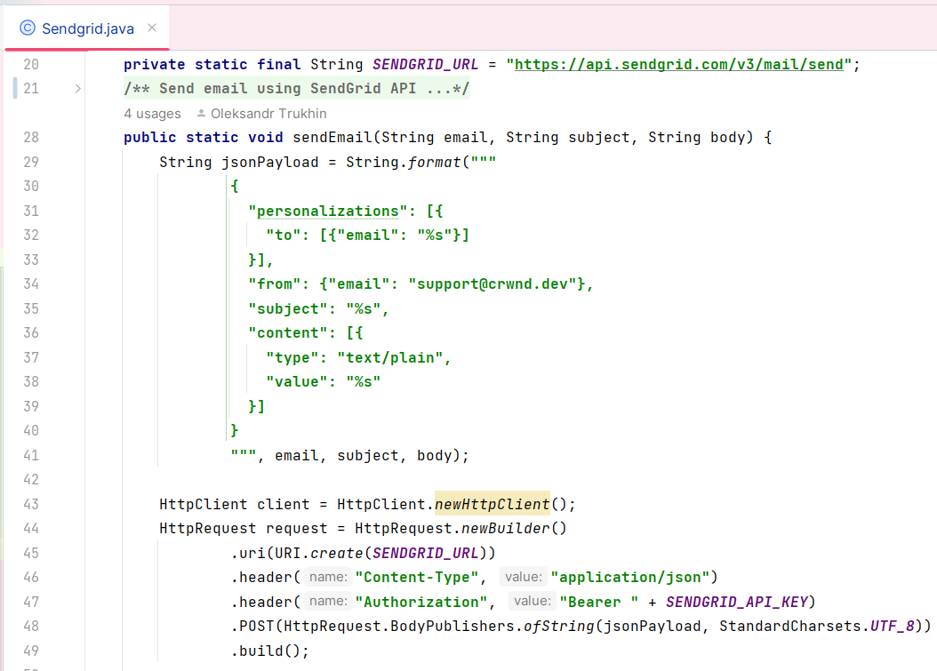

## Unit tests for business logic

We used JUnit tests for testing business logic of program in Java.

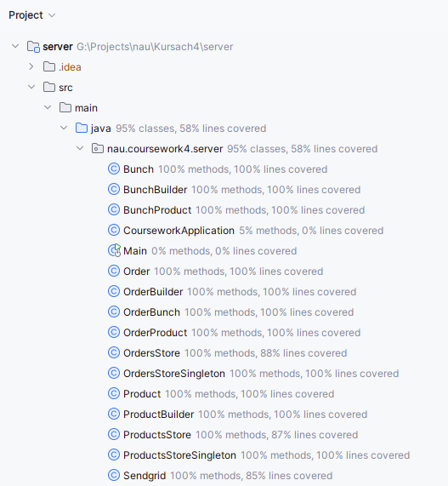

# CONCLUSION

In this course work, we developed a project - a store of flowers and bouquets. The programming language Java was used for the backend. The business logic was tested using JUnit, and the entire project was documented using JavaDoc. A web application using the Vue.js JavaScript framework was developed for the frontend.

We have developed such functionality as viewing, filtering, adding flowers and custom bouquets to the basket, controlling their quantity and cost in the order. And also developed a menu admin to manage orders and products.

I personally worked on the project with backend development, testing, documentation and database creation.

GitHubRepository: <https://github.com/alextrukhin/Kursach4>

# REFERENCES

Online article «Convert String to JsonObject with Gson»: <https://www.baeldung.com/gson-string-to-jsonobject>

Online article «Lucide Vue Next»: <https://lucide.dev/guide/packages/lucide-vue-next>

Online article «I want my textarea to have a fixed width [duplicate]»: <https://stackoverflow.com/questions/36825227/i-want-my-textarea-to-have-a-fixed-width>

Online article «Map to String Conversion in Java»: <https://www.baeldung.com/java-map-to-string-conversion>

Online article «Scaffolding Your First Vite Project»: <https://vitejs.dev/guide/#scaffolding-your-first-vite-project>

Online article «CSS Flexbox»: <https://www.w3schools.com/css/css3_flexbox.asp>